**ANSIBLE CASE STUDY**

You are a Devops Engineer and the organization you are working on needs to set up two configuration management server groups. One for Apache another for Nginx. Being a Devops Engineer it is your task to deal with this configuration management issue. Let us see the tasks that you need to perform using Ansible.

1.Create two Server Groups. One for Apache and another for Nginx. 2. Push two html files with their server information. Make sure that you don’t forget to start the services once the installation is done. Also send post installation messages for both the server groups. Using Ansible Roles accomplish the above the tasks. Also, once the Apache server configuration is done you need to install Java on that server group using ansible role in a playbook.

1. **Created two Server Groups**

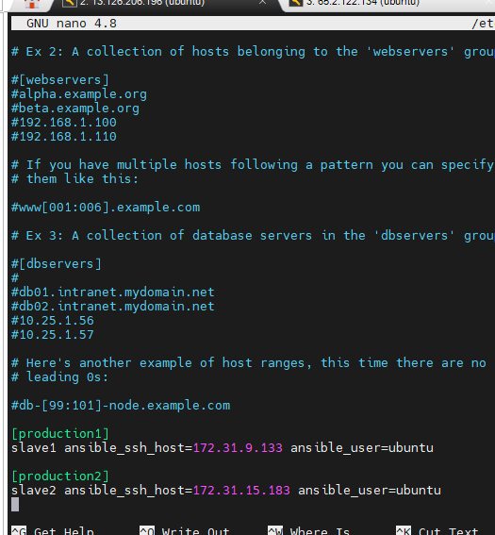

**Able to ping both server groups**

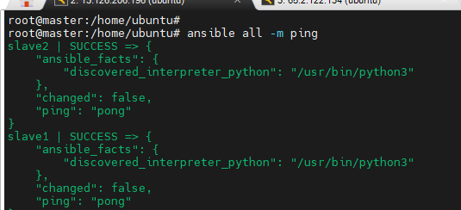

* Role 1 for installing Apache, pushing html file and installing java.

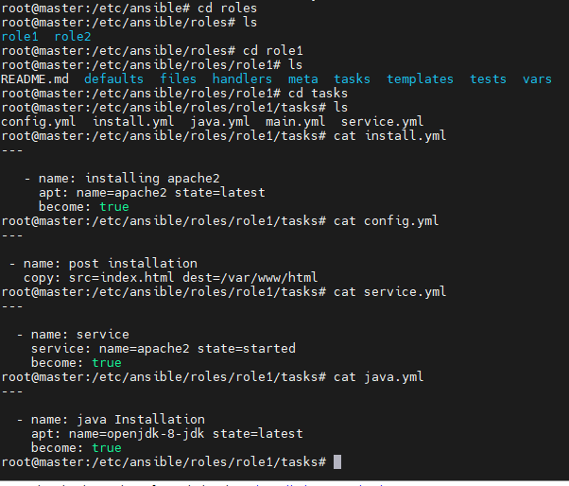

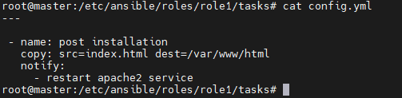

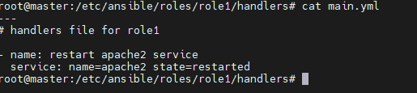

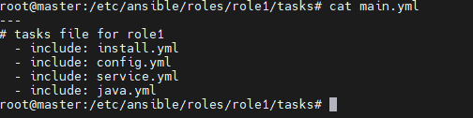

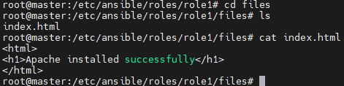

* Role 2 for installing Nginx, pushing html file.

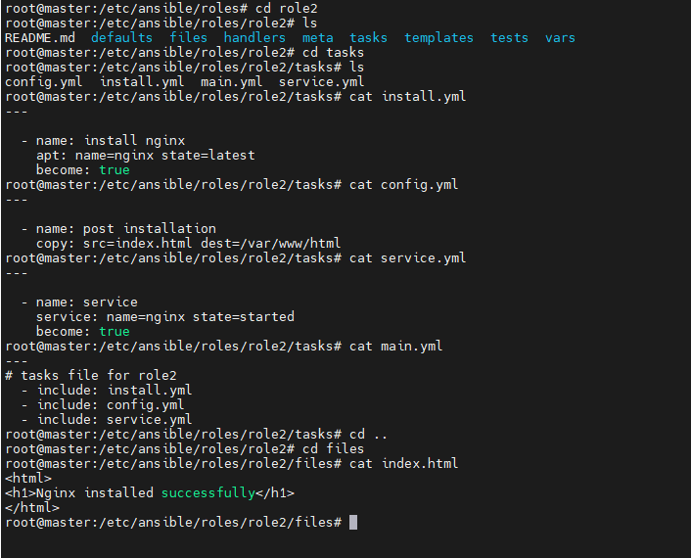

* Writing playbook

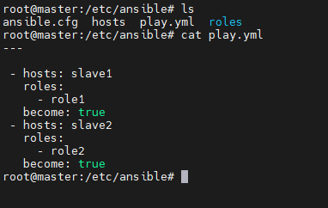

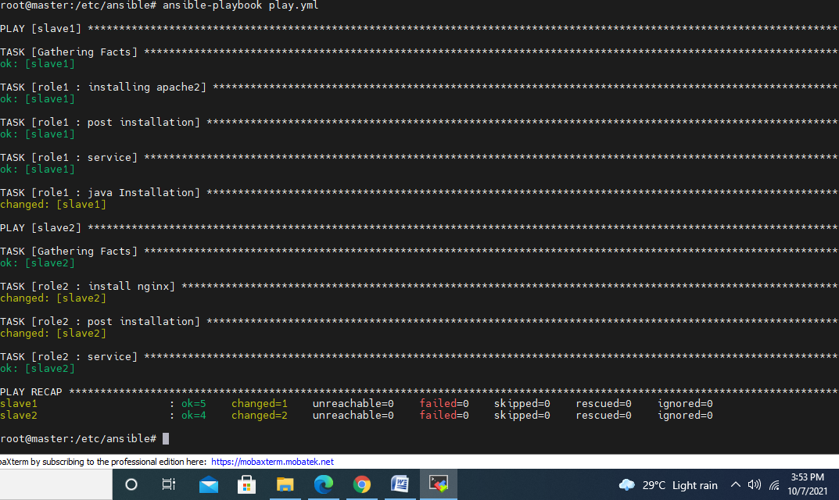



* Java is installed after apache on slave1

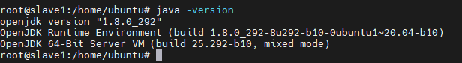

* Nginx on slave2

